ATM SIMULATOR

BY

J.THENISH REDDY - 19BCE1019

S.BHARGAVA REDDY - 19BCE1109

**A project report submitted to**

**Dr.MUTHULAKSHMI S -MAM**

**SCHOOL OF COMPUTER SCIENCE & ENGINEERING**

**in partial fulfilment of the requirements for the course of**

**CSE 2006 – MICROPROCESSOR AND INTERFACING**

IN

**B. Tech. COMPUTER SCIENCE ENGINEERING**



**Vandalur – Kelambakkam Road**

**Chennai – 600127**

**JUNE 2021**

**ABSTRACT**

The ATM Service is the project which is used to access their bank accounts in order to make cash withdrawals. Whenever the user need to make cash withdraws, they can enter their PIN/PASSWORD (personal identification number)

And it will display the amount to be withdrawn in the multiples of 500’s. Once their withdrawn was successful, the amount will be debited in their account.

The ATM Service is developed in Assembly language program. Hence we use the software, EMU 8086 MICROPROCESSOR EMULATOR

The ATM will service one customer at a time. A customer will be required to enter ATM Card number or their respective netbanking password ,personal identification number (PIN) – both of which will be sent to the database for validation as part of each transaction. The customer will then be able to perform one or more transactions. Also customer must be able to make a balance inquiry of their account.

In addition to withdraw the amount we are also adding one rare feature where one can transfer money to others. This option you will find very rarely in other ATM service machines.

This is the unique and most wanted feature to all the users, who want to send money remotely to others with ease. And we are looking forward to add some other cool features.

**BONAFIDE CERTIFICATE**

Certified that this project report entitled “**ATM SIMULATOR ”** is a bonafide work of  **J.THENISH REDDY - 19BCE1019 and** S.**BHARGAVA REDDY - 19BCE1109** who carried out the Project work under my supervision and guidance for **CSE2006- MICROPROCESSOR AND INTERFACING.**

**Dr. MUTHULASKHMI.S**

Professor Sr.

School of Electronics Engineering

(SENSE), VIT University,

Chennai

Chennai – 600 127.3

**TABLE CONTENT**

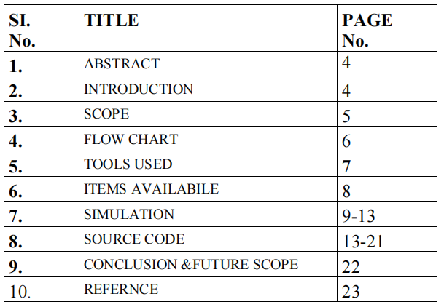

**ACCKNOWLEDGEMENT**

We wish to express our sincere thanks and deep sense of gratitude to our

project guide, **Dr.MUTHULAKSHMI.S.,** Professor Sr., School of Electronics

Engineering, for her consistent encouragement and valuable guidance offered to

us in a pleasant manner throughout the course of the project work.

We also take this opportunity to thank all the faculty of the School for their

support and their wisdom imparted to us throughout the course.

Engineering, for her consistent encouragement and valuable guidance

offered to us in a pleasant manner throughout the course of the project

work

1. INTRODUCTION

*Automated Teller Machine enables the clients of a bank to have access to their account without going to the bank*

When the product is implemented, the user who uses this product will be able to see all the information and services provided by the ATM, when he enters the necessary option and arguments.

The product also provides services like request for cheques, deposit cash and other advanced requirement of the user.

The data is stored in the database and is retrieved whenever necessary.

***To develop this ATM system the entire operation has been divided into the following step:***

*1. Verification process.*

*2. service and account selection .*

*3. Balance Enquiry.*

*4. Money Withdraw.*

*5. Transfer Money.*

*6. Exit the service.*

* 1. MAIN OBJECTIVE

Now- a -days every one very busy in their work. So they feel that the job must be easier so the system is used to reduce their work which is done in the ATM system. Instead of keeping lots of paper into a record or file and it may be missed somewhere so, this system help to keep the record of the customer it also keeps the details of customer

• It is also easy to access.

• To render accurate services to customer.

* 1. **SCOPE OF OUR PROJECT**

Provides Customer to:

Financial Flexibility.

•World wide acceptance.

•Round the clock convineince.

•Fund Transfer

• Withdrawal and Balance Enquiry.

WORKING MECHANISM

* The program is designed in such a way that the user has to enter pin number. Once verified, he is provided a menu and he/she had to enter the option provided in the menu.
* For example, when the user wants to view the list of Balance Enquiry then he/she had to enter the option for Balance Enquiry provided in the main menu. When the option is entered alone with the respective argument, then the Balance Enquiry is displayed on the screen.
* The user also must be given option to browse through the pages like previous page, next page, or exit out of the service etc.

BENEFITS

FOR THE BANK :

* + Increases existing business.
  + Generates new business.
  + Provides additional revenue streams.
  + Reduces the workload of **bank** staff

FOR THE CUSTOMER :

* + Saves time and money.
  + Can get cash whenever and wherever required.
  + Security Features
  + Convenient 24X7 Banking
  + Universally Accepted

Overview of the project:

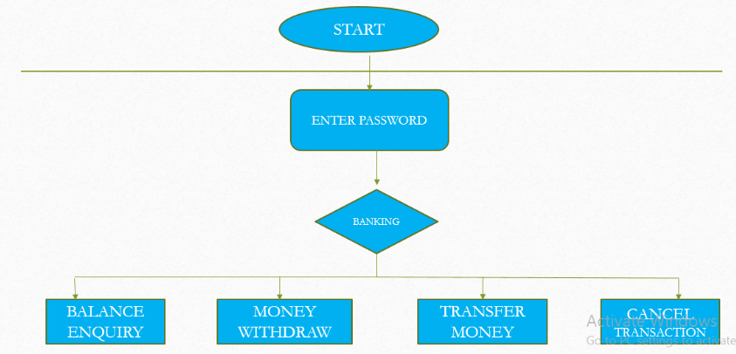

TECHNICAL PHASE DIVISIONS:

PHASE 1 : PASSWORD CHECK  
  
PHASE 2 : DISPLAY BANKING OPTIONS  
  
PHASE 3 : BALANCE ENQUIRY  
  
PHASE 4 : MONEY WITHDRAW  
  
PHASE 5 : TRANSFER MONEY  
  
PHASE 6 : CANCEL TRANSACTION

***PHASE 1 : CODE FOR PASSWORD CHECK***

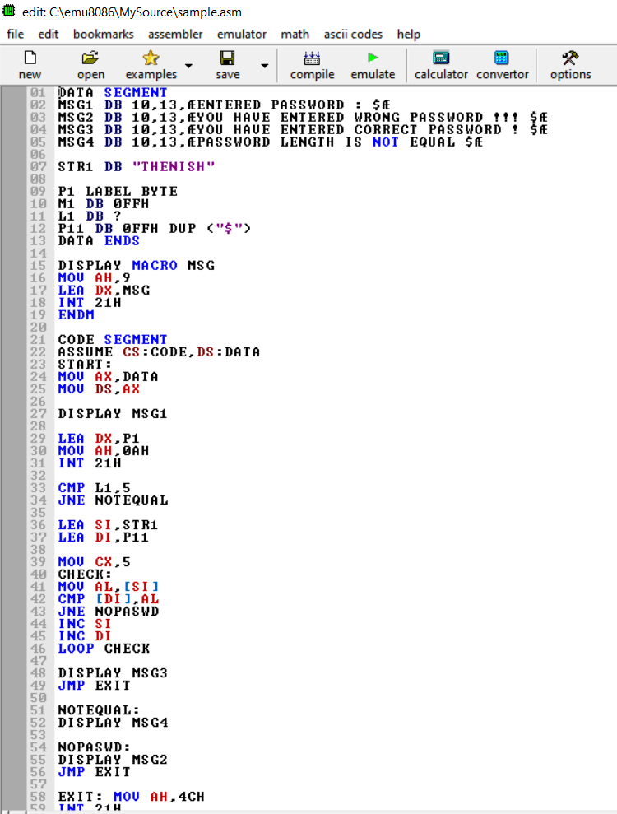

***AFTER EXECUTION***

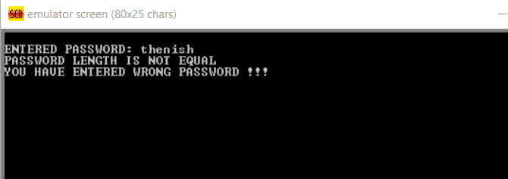

***PHASE 2 : DISPLAY BANKING OPTIONS***

This is the phase 2 of our project . Here, In this Phase 2 after entering the correct password ,Three options will display the user can use of their choice.

* 1. BALANCE ENQUIRY
* 2. MONEY WITHDRAW
* 3. TRANSFER MONEY
* 4. CANCEL TRANSACTION

***CODE FOR DISPLAY OF BANKING OPTIONS***

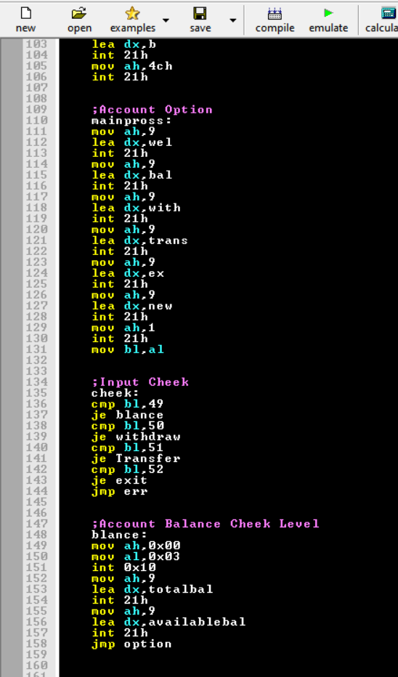

* ;Options Phase
* wel db 10,13," Welcome to Your Account $"
* bal db 10,13,10,13,"1. Balance Inquiry $"
* with db 10,13,"2. Money Withdraw $"
* trans db 10,13,"3. Transfer Money $"
* ex db 10,13,"4. Exit $"
* bac db 10,13,"1. Back$"
* ext db 10,13,"2. Exit$

***AFTER EXECUTION***

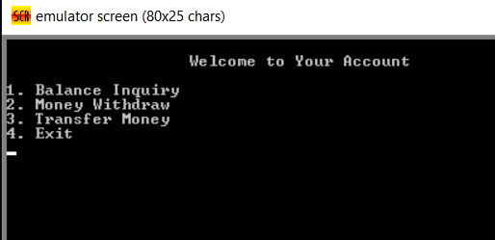

**PHASE 3 : BALANCE ENQUIRY**

**CODE:**

totalbal db 10,13,"Your Total Balance is: 25,000 USD $"

availablebal db 10,13,"Your Available Balance is: 24,900 USD $"

-> Since Minimum Balance should maintain in the particular account

-> So, ATM will display two types of balances Total and Available balance

***AFTER EXECUTION***

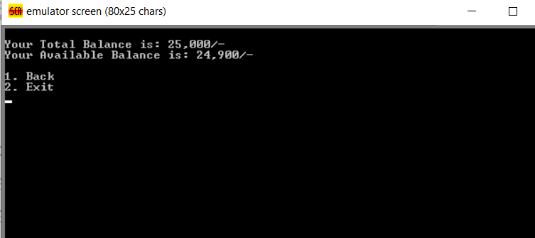

***PHASE 4 : MONEY WITHDRAW (CHOICE OF 7 TYPES OF AMOUNT TO WITHDRAW)***

CODE:

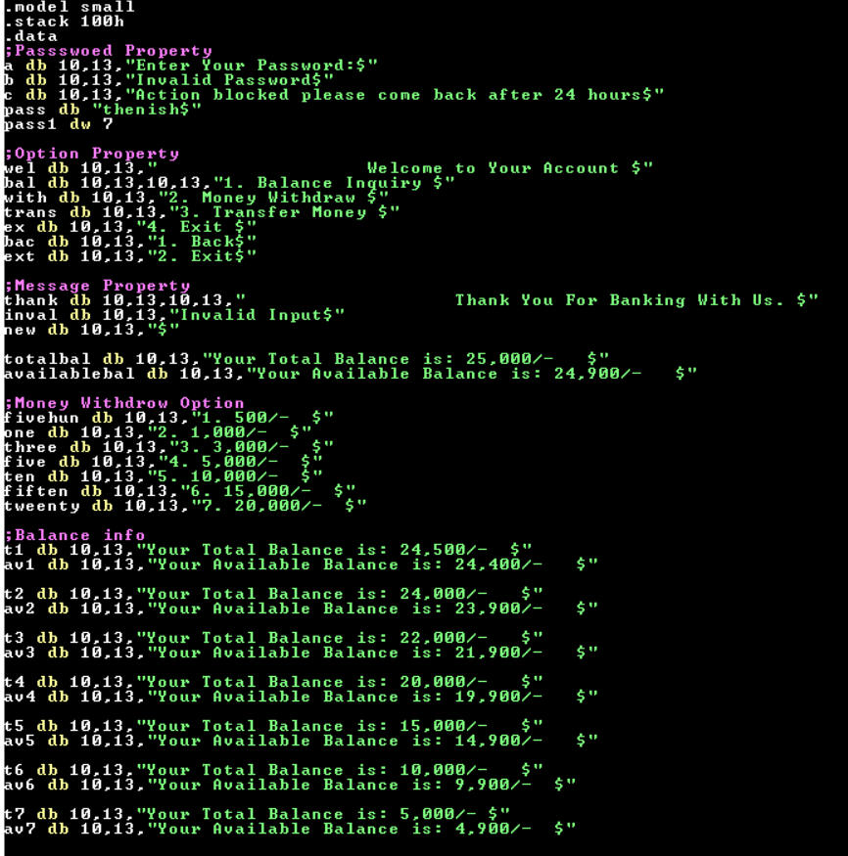

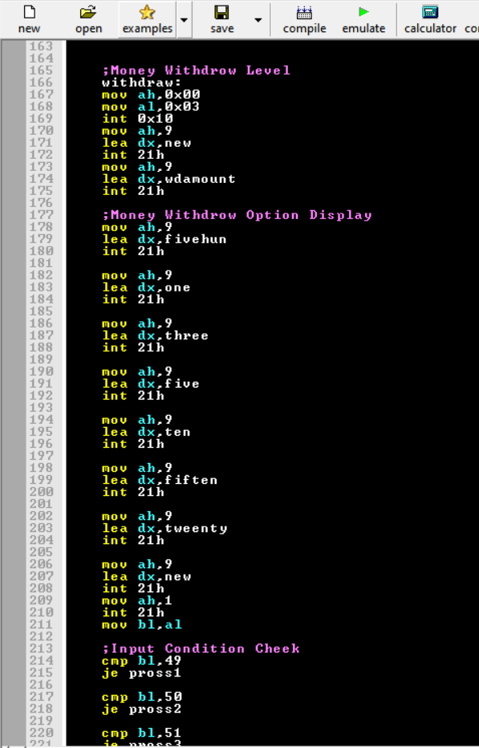

AFTER EXECUTION:

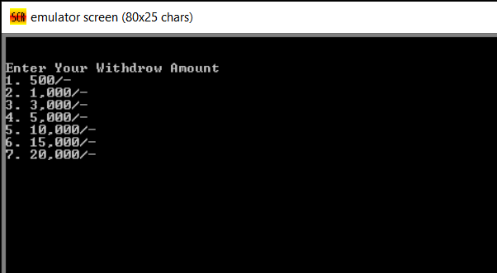

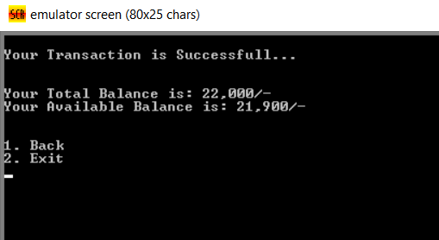

**PHASE 5 : TRANSFER MONEY**

CODE FOR PRINT STATEMENTS:

accountnum db 10,13,"Enter Account Number: $"

tranamount db 10,13,"Enter Your Transaction Amount$"

success db 10,13,"Your Transaction is Successfull...$"

***LOGIC :***

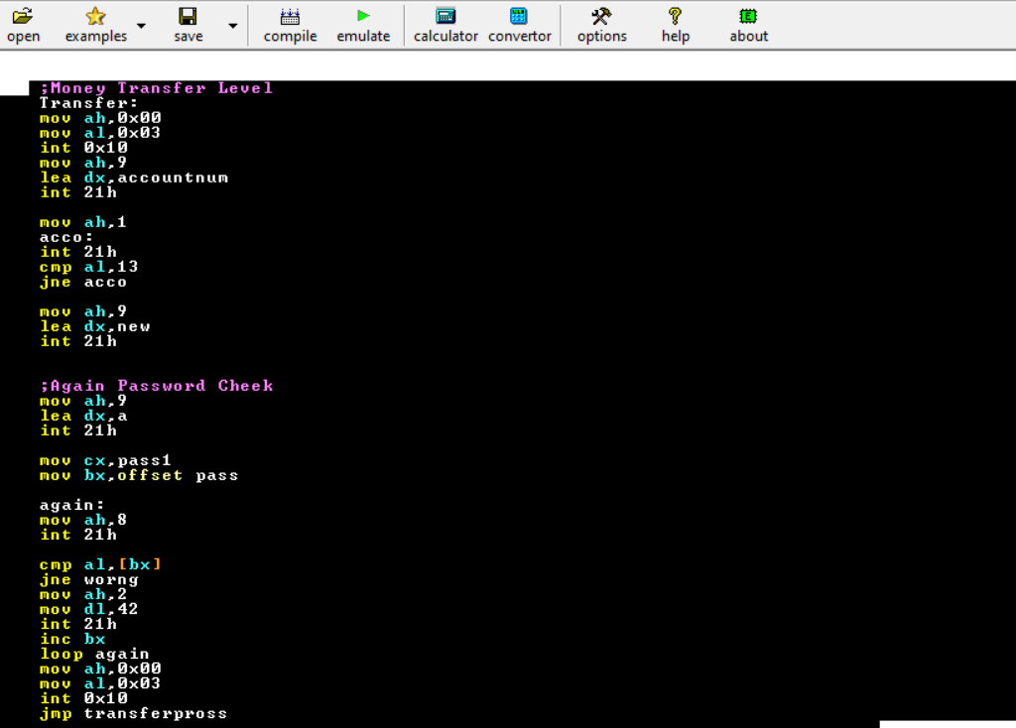

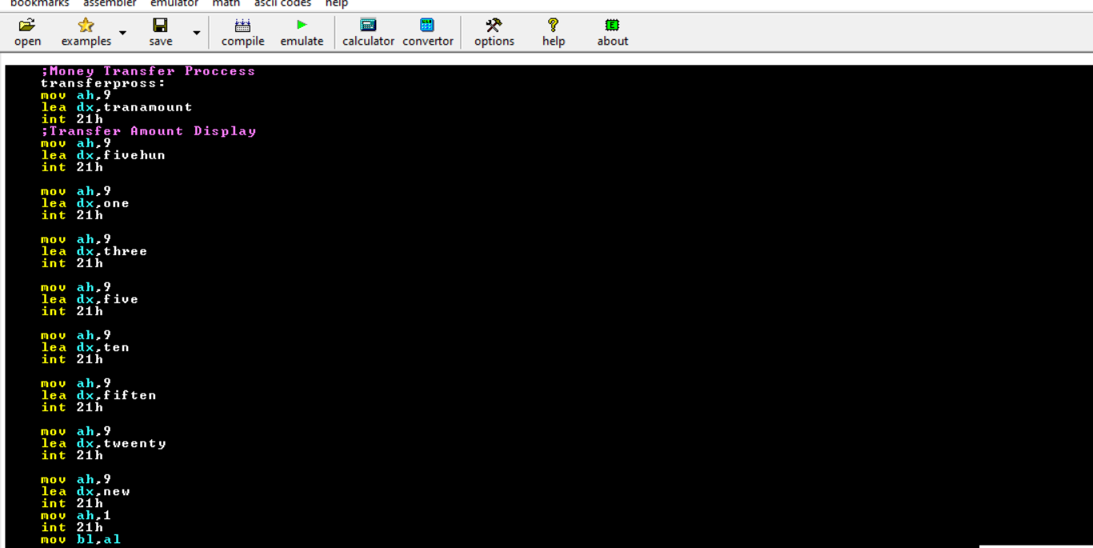

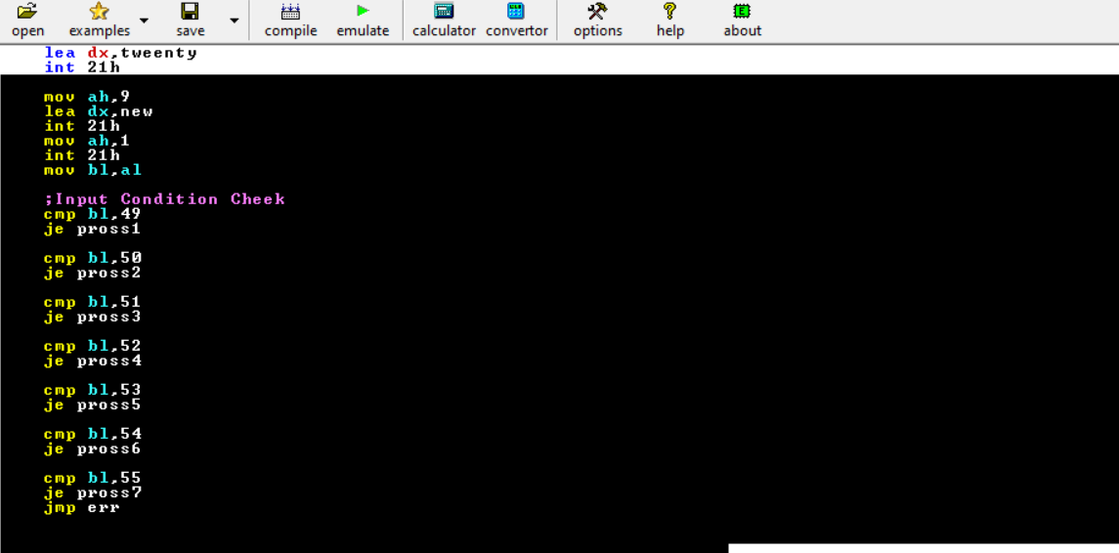

**AFTER EXECUTION:**

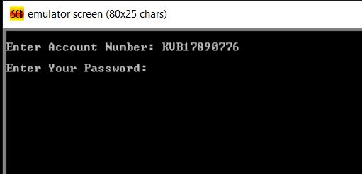

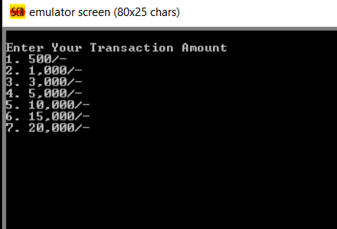

After selecting option 2 (Transfer of 1000 USD):

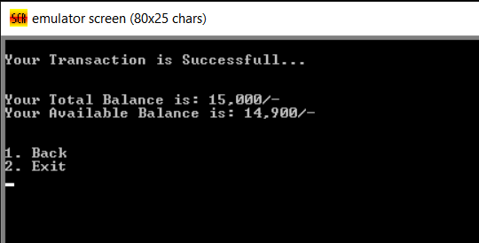

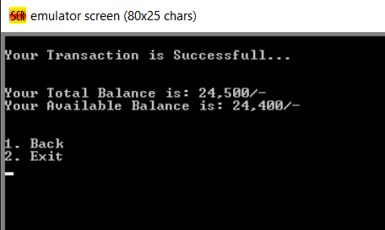

**PHASE 6 : CANCEL TRANSACTION**

Print statement line:

thank db 10,13,10,13," Thank You For Banking With Us. $"

**CODE:**

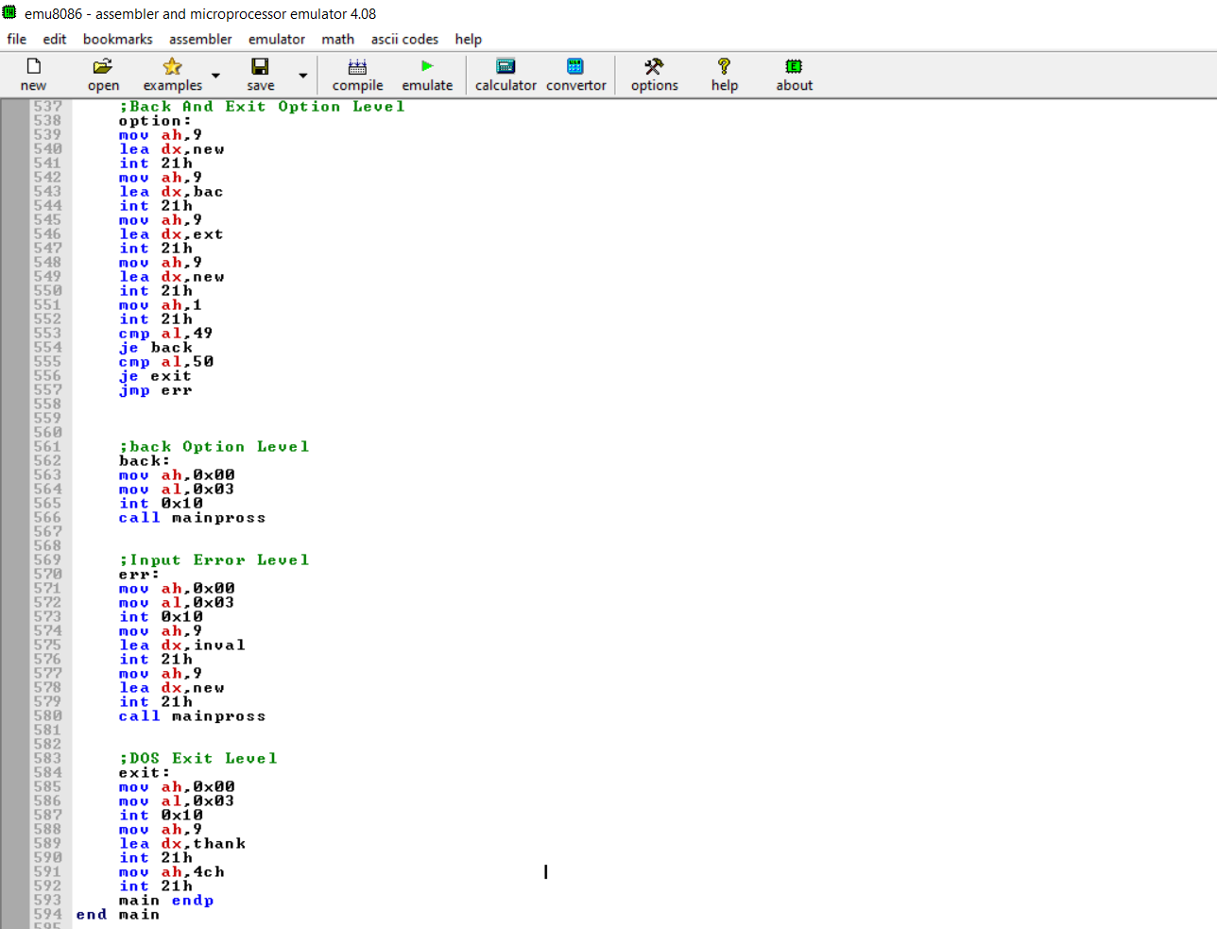

**AFTER EXECUTION :**

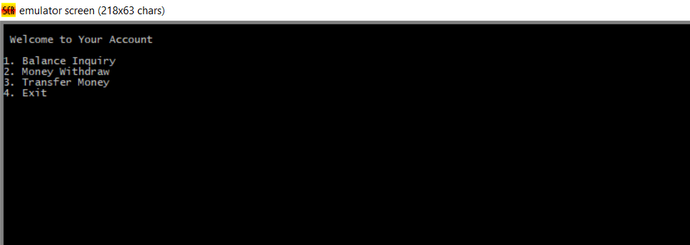

Selecting option 4 for cancel the transaction

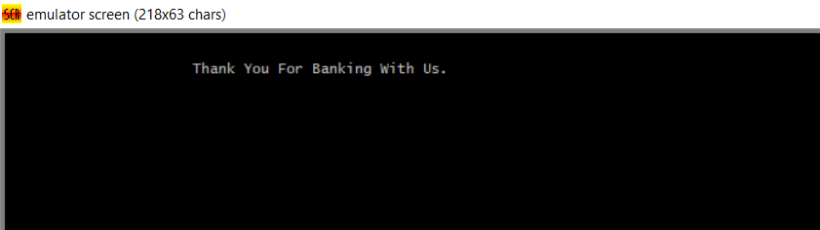

Displays a pop-up message “Thank You For Banking with us”.

**OVERALL SNIPPET CODE:**

Snippet code for working the Entire model

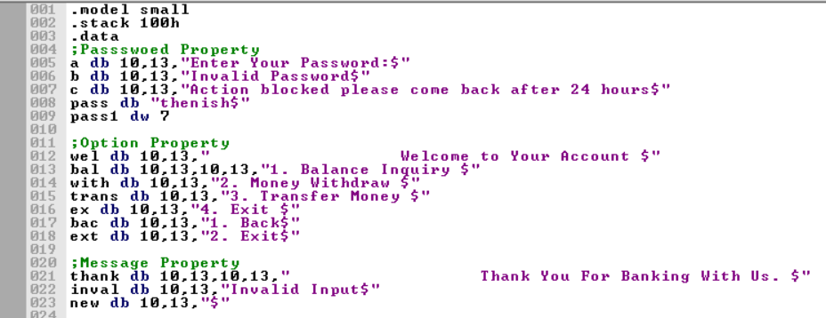

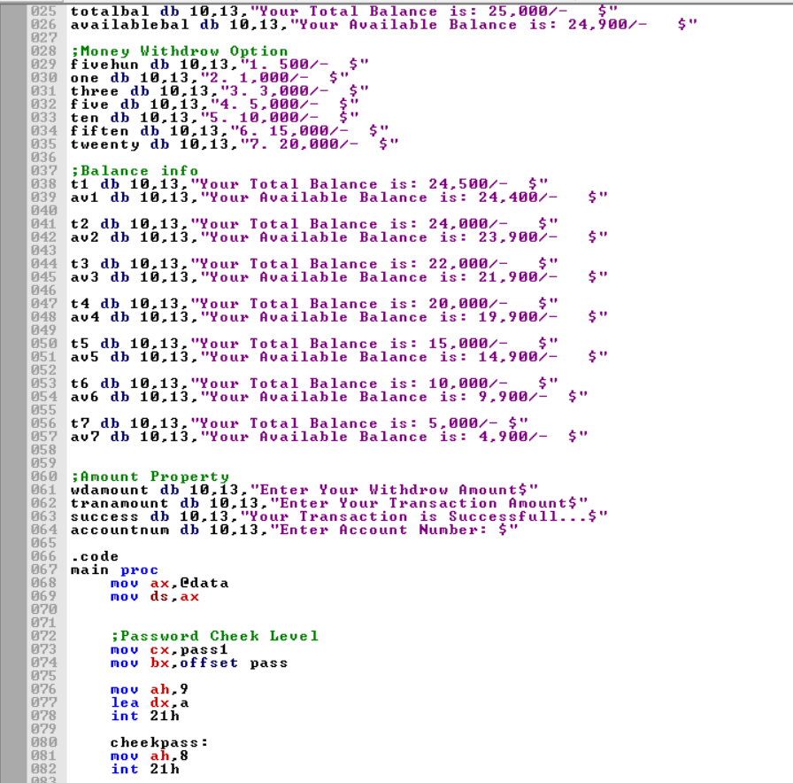

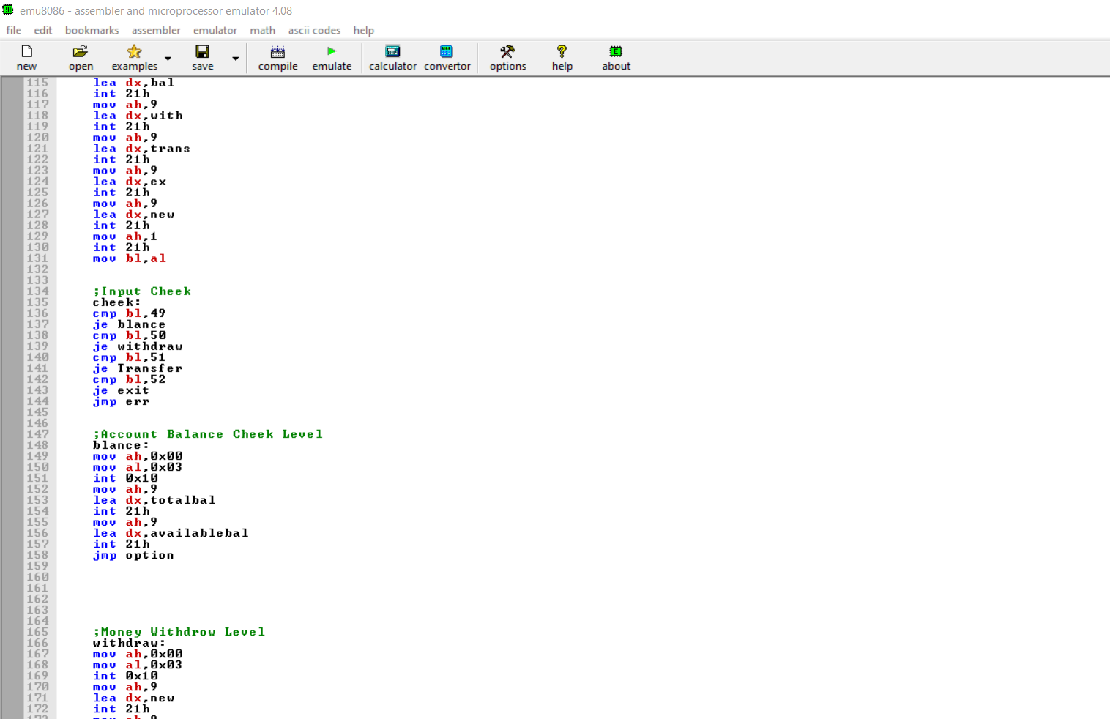

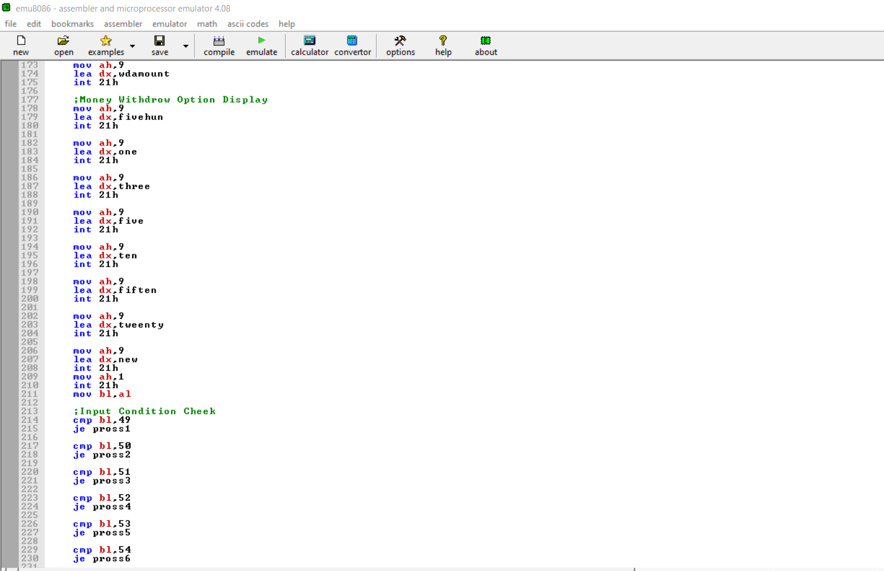

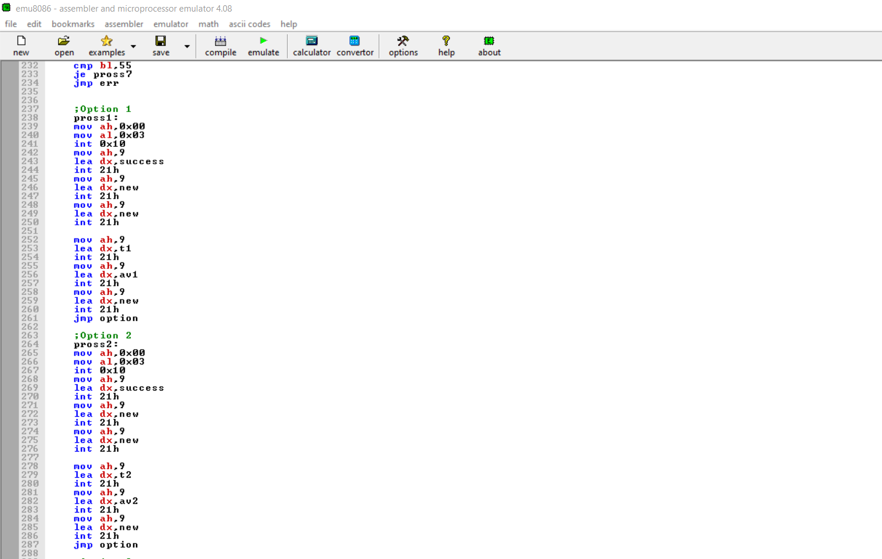

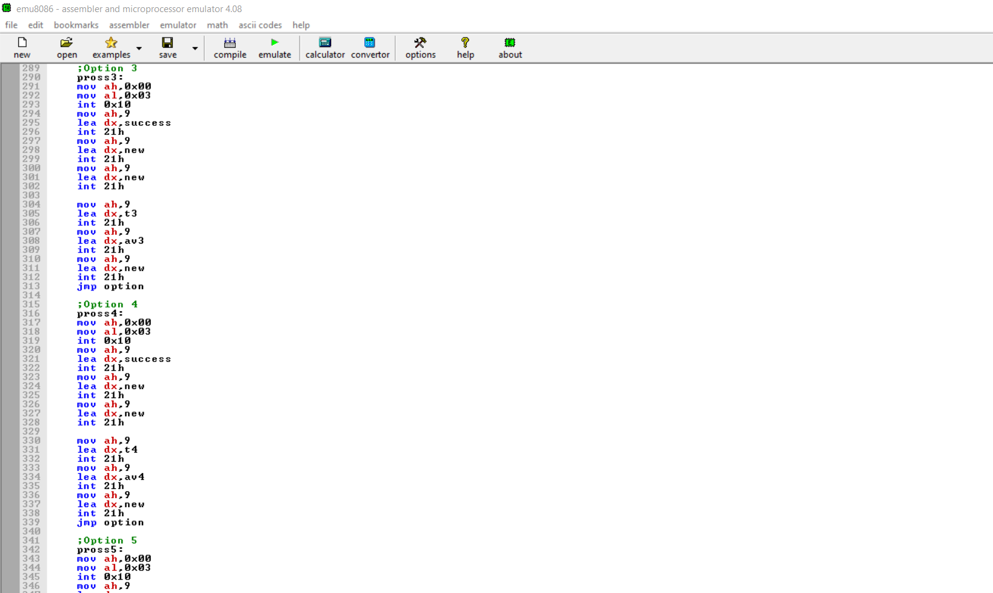

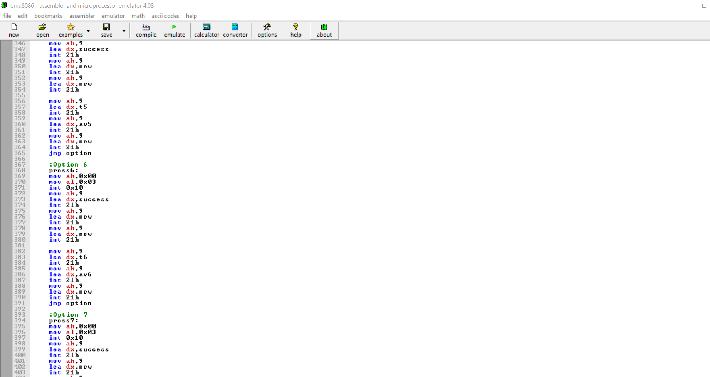

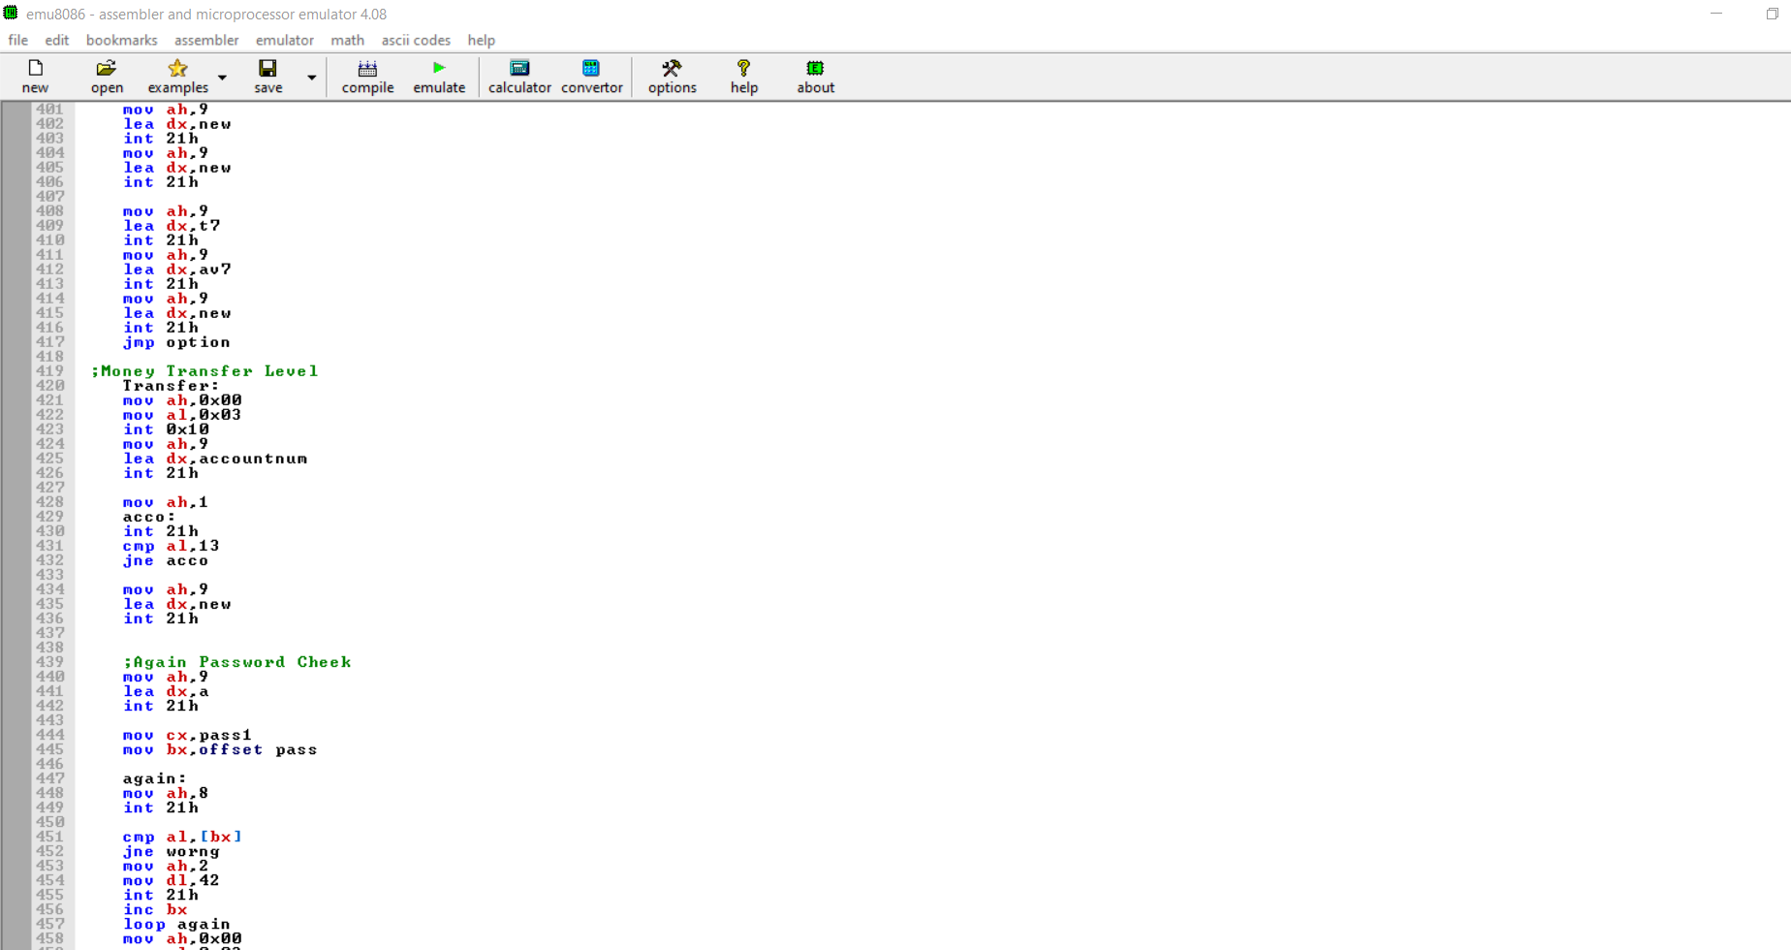

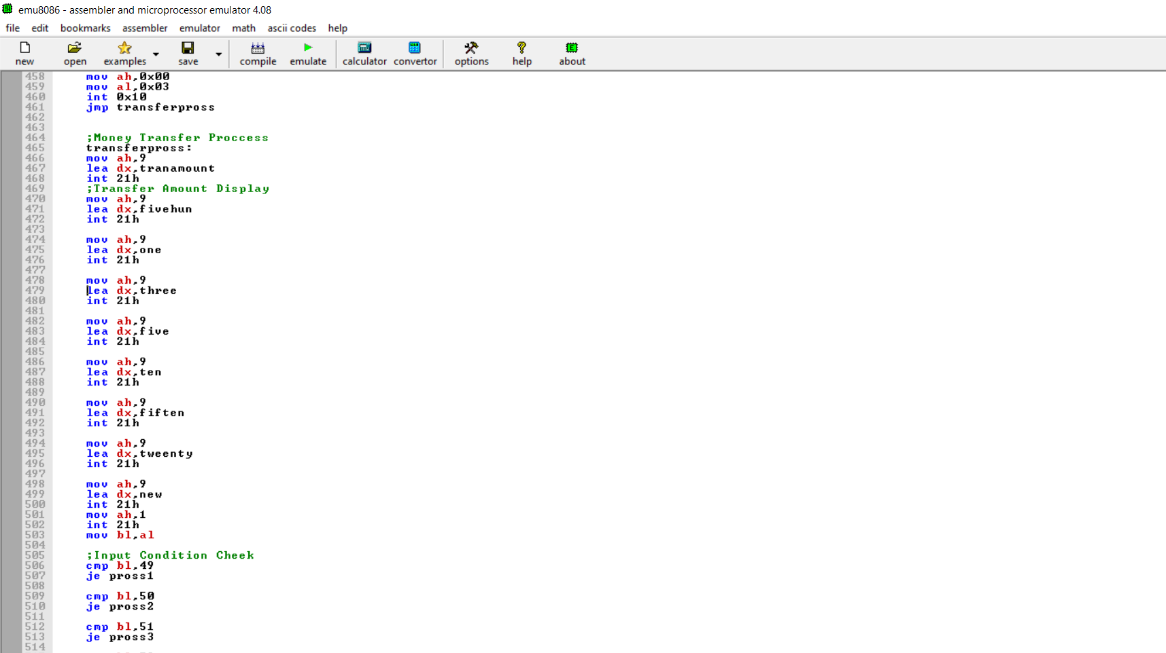

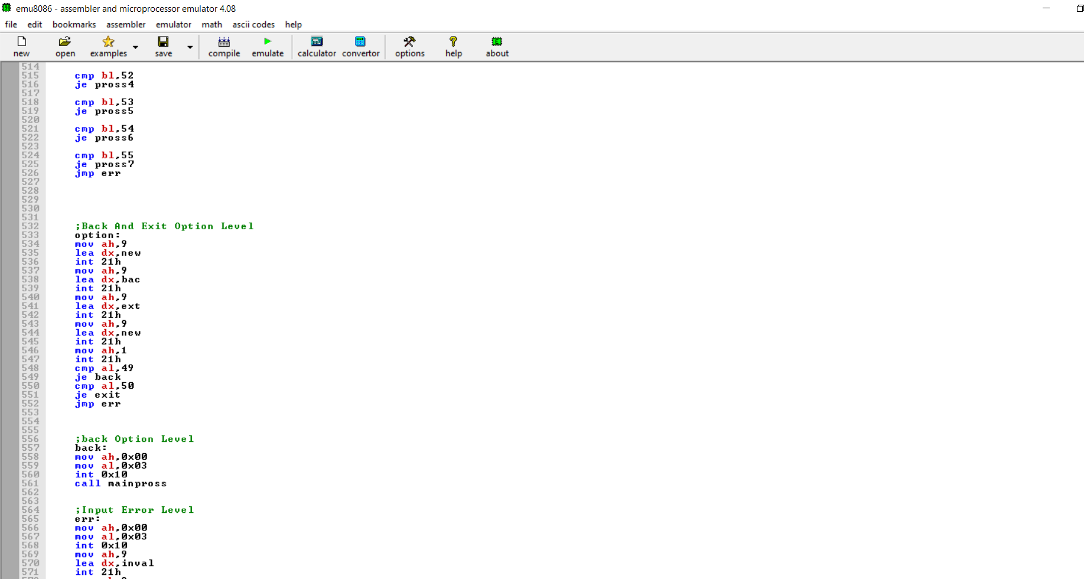

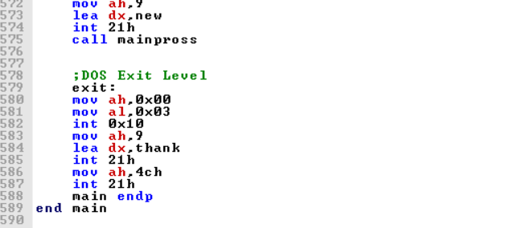

Video link : <https://drive.google.com/file/d/1HkEqn-LBkp86yXA0X8AolxxJamtuvUpk/view?usp=sharing>

**CONCLUSION**

* we can observe that an ATM system is associated with the bank transactions of the consumers
* Majorly, the ATM system is utilized for the money associated transactions from the consumers.
* Consumers make major use of ATM to withdraw money from their bank account
* It is a fast way to get money out of your account especially when on the go or during a trip